Privacy Settings
Choose how much information you want to share with Microsoft

After the release of Windows 10 operating system, lots of people are worried about their privacy in Windows 10. People think that Microsoft is collecting their personal data in Windows 10 OS which is absolutely wrong. Microsoft just collects some required basic data anonymously to improve Windows 10 functionality and suggestions which are given by the OS to the end user i.e. you.

If you are worried about Windows 10 privacy issues and want to get maximum privacy in Windows 10, this workshop will definitely help you. We'll review and suggest best privacy settings for Windows 10 which will allow you to disable automatic data collection and telemetry* in Windows 10 to help you get as much privacy as you like in the OS. You'll be able to configure Windows 10 privacy settings quickly and easily with the help of this workshop.

*Telementrry, the process of collecting data and transmitting it to remote receiving equipment.

Configure Windows 10 Privacy Settings after Installation
If, when you installed Windows 10 you didn't customize your privacy settings you can still configure those privacy settings along with many other settings using the Settings app:
- Open Start Menu and click on “Settings”.
- Click on "Privacy".
You will note that Microsoft split the privacy menu into two sections: Windows Permissions and App Permissions.
“Windows Permissions” deals with how Microsoft collects and uses your data.
“App permissions” deals with how installed apps use data collection and other privacy-related app permissions.
Microsoft has made many privacy decisions for you (or best for them) and here we will review and offer our suggestions.
① Windows Permissions

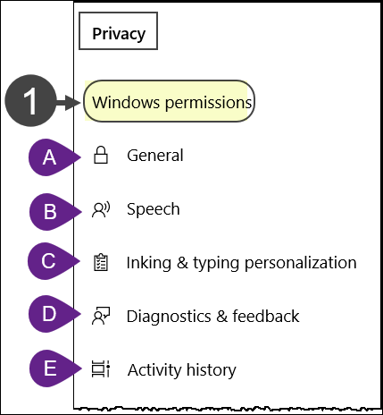
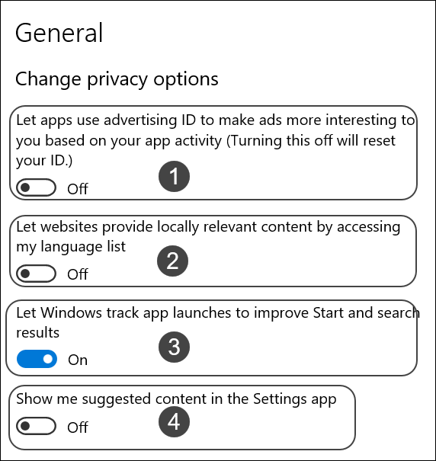
Ⓐ General
Fig. 1
Fig. 2

Change privacy options (Fig. 2)

This is a matter of personal preference. You’re likely to see ads if you use the internet so, do you want those ads personalized to your viewing and purchasing decisions? (Off).
By default, websites will automatically provide locally relevant content by accessing the language list in your computer, which could be troublesome for some users. (Off).
Microsoft uses your browsing, search, and other online activity data associated with your Microsoft account. Disable the option to improve you privacy and prevent Windows 10 from tracking the apps you launch. Enable the feature to get the Most Used apps functionality and improve your search results in Cortana and Settings. (On).
Microsoft can offer you suggestions throughout Settings. This content comes in a variety of forms, and can help you discover new features within Settings, or suggest new content and apps you may find interesting.
Toggle this option on or off depending on what you want to achieve. Turning it “Off” will mean that you will no longer see any suggested content.

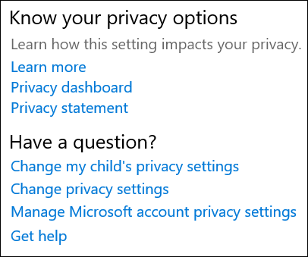
Know your privacy options
Fig. 2A
Below this heading (Fig. 2A) are a number of links that include additional information and are worth exploring on your own.

ⒷSpeech
When online speech recognition is turned on, you can use your voice for dictation and to talk to Cortana and other apps that use Windows cloud-based speech recognition. Microsoft will use your voice data to help improve their speech services.
When online speech recognition is turned off, you won't be able to speak to Cortana or use dictation. You can still use the Windows Speech Recognition app and other speech services that do not rely on Windows cloud-based services. (On).

Ⓒ Inking & typing personalization
Like many privacy options turning them on or off is a personal preference. We prefer turning this option “Off”.

Ⓓ Diagnostics & feedback
You must be aware of the Diagnostic and Feedback settings which allows Microsoft to collect performance and usage information helps Microsoft to troubleshoot issues with Windows, improve their product & services and resolve bugs as soon as possible.
- Diagnostic data: If you're a member of Windows Insider program the option "Full" is turned on automatically. If not, the entire option is greyed out. As a member of the “Insider Program” the information collect is important to Microsoft for making product improvements.
- Improving inking and typing: If you choose to turn on Improve inking & typing, Microsoft will collect samples of the content you type or write to improve features such as handwriting recognition, auto completion, next word prediction and spelling correction, and we use this data in the aggregate to improve the inking and typing feature for all users. (Off).
- Tailored experiences: If you choose to turn on “Tailored experiences”, Microsoft will use your diagnostic data to offer you personalized tips, ads, and recommendations to enhance Microsoft products and services for your needs. This option ties into Windows attempting to streamline your user experience. Turn this option “Off” to stop these suggestions.
- View diagnostic data: You can view diagnostic data for your device in real time by using the Diagnostic Data Viewer app. The Diagnostic Data Viewer option gives you a chance to view the data Microsoft is collecting on your system. If you like to know, turn the option “On” and click “Open Diagnostic Data Viewer. (Off).
- Delete diagnostic data: You can delete diagnostic data for your device. Selecting this option does not delete the diagnostic data that is associated with your user account, nor does it stop your diagnostic data from being sent to Microsoft.
- Feedback Frequency: This option is set to “Automatically” if you are a member of the Insiders Program (greyed out if not) and Microsoft will occasionally display a message asking you to rate or provide written feedback about the product or services you use.
- Recommended troubleshooting: Windows 10 devices get recommended troubleshooting for problems Microsoft knows about and problems found in diagnostic data sent to Microsoft. They might determine that a problem is impacting a specific set of devices based on Windows version information, user feedback, error information, device settings, hardware configuration, and device capabilities such as installed apps and drivers. They will let you know when we can help, and you can choose to run the troubleshooter or ignore it.

Fix problems for me without asking: Recommended fixes will apply automatically without any user interaction or knowledge.
Tell me when problems get fixed: Issues will be fixed automatically without the need of user interaction, but Windows 10 will notify any changes.
Ask me before fixing problems (default): You'll receive a notification to review the recommendation along with an option to run or ignore the fix.

Once you complete the steps, Windows 10 will try to fix problems using the settings that you specified. You must be connected to the internet to use recommended troubleshooting.

Ⓔ Activity History
Activity history keeps track of the things you do on your device, such as the apps and services you use, the files you open, and the websites you browse. Your activity history is stored locally on your device, and if you’ve signed in to your device with a Microsoft account and given your permission, Windows sends your activity history to Microsoft.
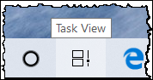
If you enabled the setting to “send my activity history to Microsoft”, not only would you see activity in your timeline for up to 30 days, but you could also see it from another device.
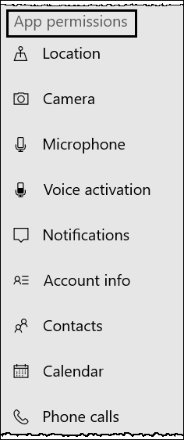
Windows Timeline feature uses your activity history. Timeline is a history of activities you viewed in the past. It allows you to reopen a web page you had opened in the past 30 days (using Microsoft Edge), reopen a Word document or pick up an app where you left off. Timeline is available by clicking the “Task View” icon located on the taskbar.
Fig. 3
- Show activities from these accounts: If you turn this setting off you will only be able to see your browsing history in Microsoft Edge. (On).
- Clear activity history: Select “Clear” and you can delete both the activity history stored on your device and sent to the Microsoft cloud.
- Click the link “Manage my Microsoft account activity data” and scroll down to “Apps and services”. Click the link to review and edit the list of apps you may have given permission to access your data.

② App Permissions
Some installed apps or games in Microsoft Store are designed to take advantage of specific hardware or software capabilities on your Windows device. A photo app might need to use your phone's camera, or a restaurant guide might use your location to recommend nearby places.
It’s a good idea to review app permissions from time to time just to make sure that no app is accessing important things without your consent.

Each app contains information about what precisely that permission does, and why you might want to disable access to the permission. For example, apps with the notification permission can send you notifications, while apps with the radios permission can turn radios like your Bluetooth radio on and off. Let’s take a look at a couple of apps and their permissions.

Account info (Fig. 4)
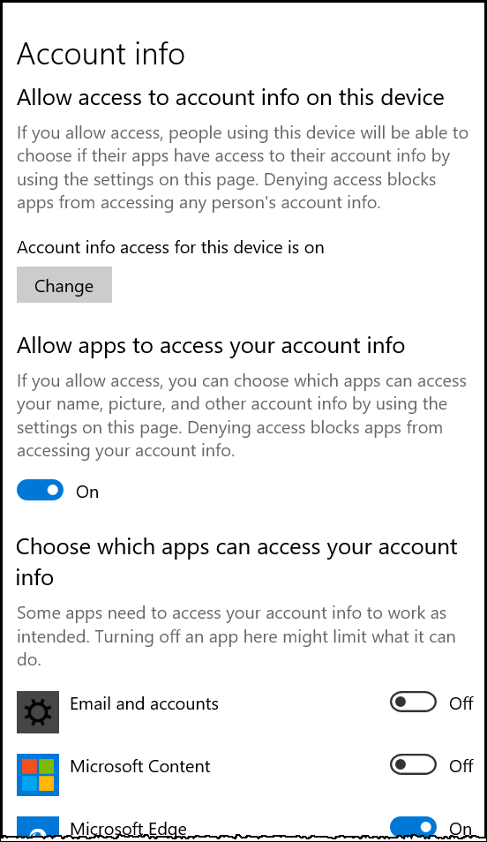
- Allow access info access…“On” by default, denying access blocks app from accessing any person’s account info. We suggest not to “Change” this option.
Fig. 4
- Allow apps to access your account info: If you allowed access you can choose what an app can access. (On).
- Choose which apps can access your account info: Toggle the switches on or off for which files you want the app to have access. Some apps need to access your account to work as intended, Microsoft Edge for example.
Select any other app and the number of apps that can access the app changes based on the apps need.
- Select “Camera”, then “Email”, then “Location” to view separate app access lists.
Please note that this method is only applicable to apps (built-in apps as well as apps from Store), meaning you can’t change permissions for traditional desktop programs.

____________________________________

Workshop Notes

Class instruction, studying the lessons of this workshop and repeating them at home, are all-essential in promoting learning.

We cannot emphasize enough the importance of practicing at home.

